# RAP-03-BO-Corresponding Implementation

<https://youtu.be/bZSC_mCRJ7c?list=PLqz8SLrkjv2iwPtPRJ4V6zJRfgNrgZKlQ>

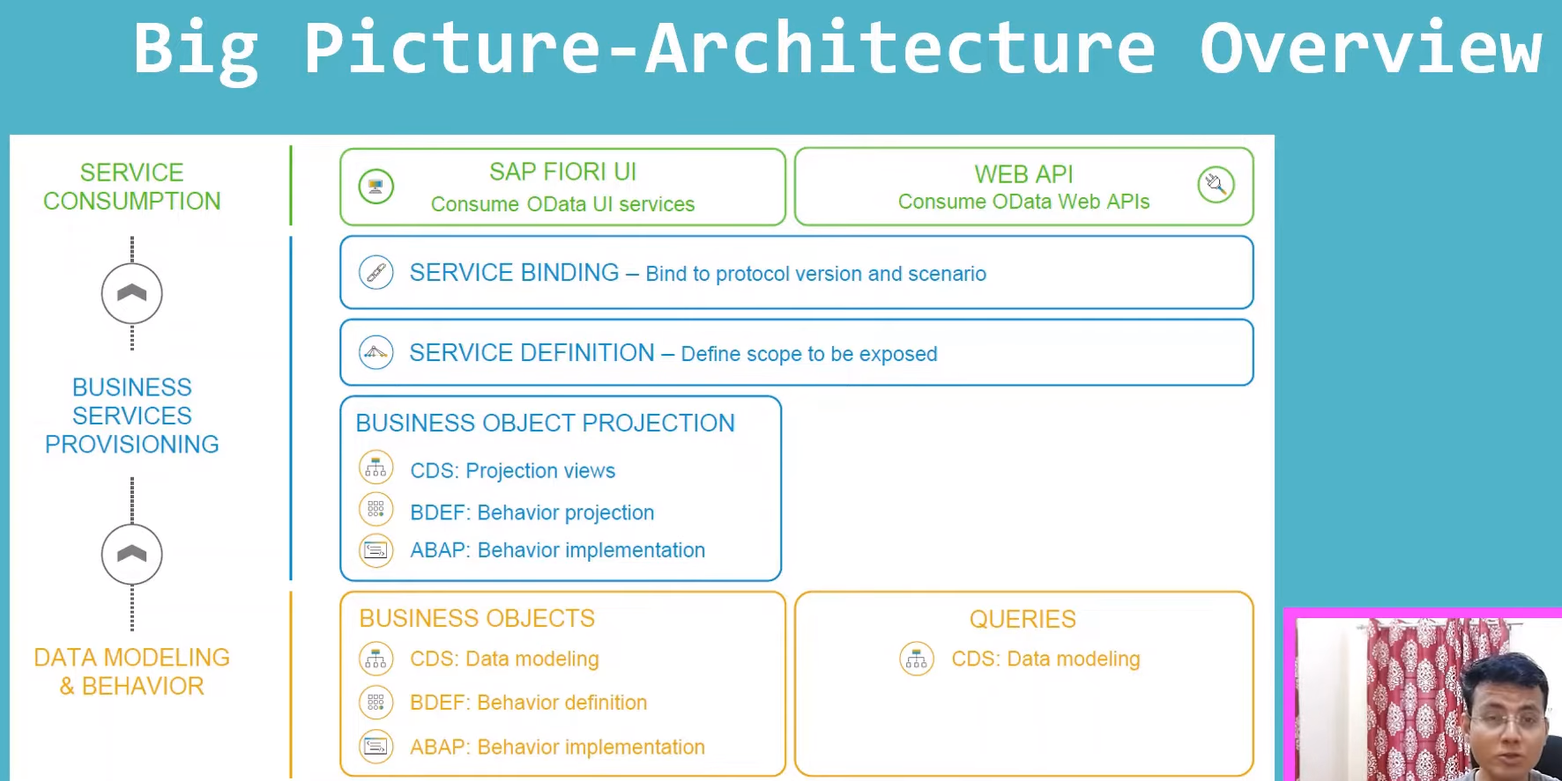

## Data Modeling & Behavior- Part-2

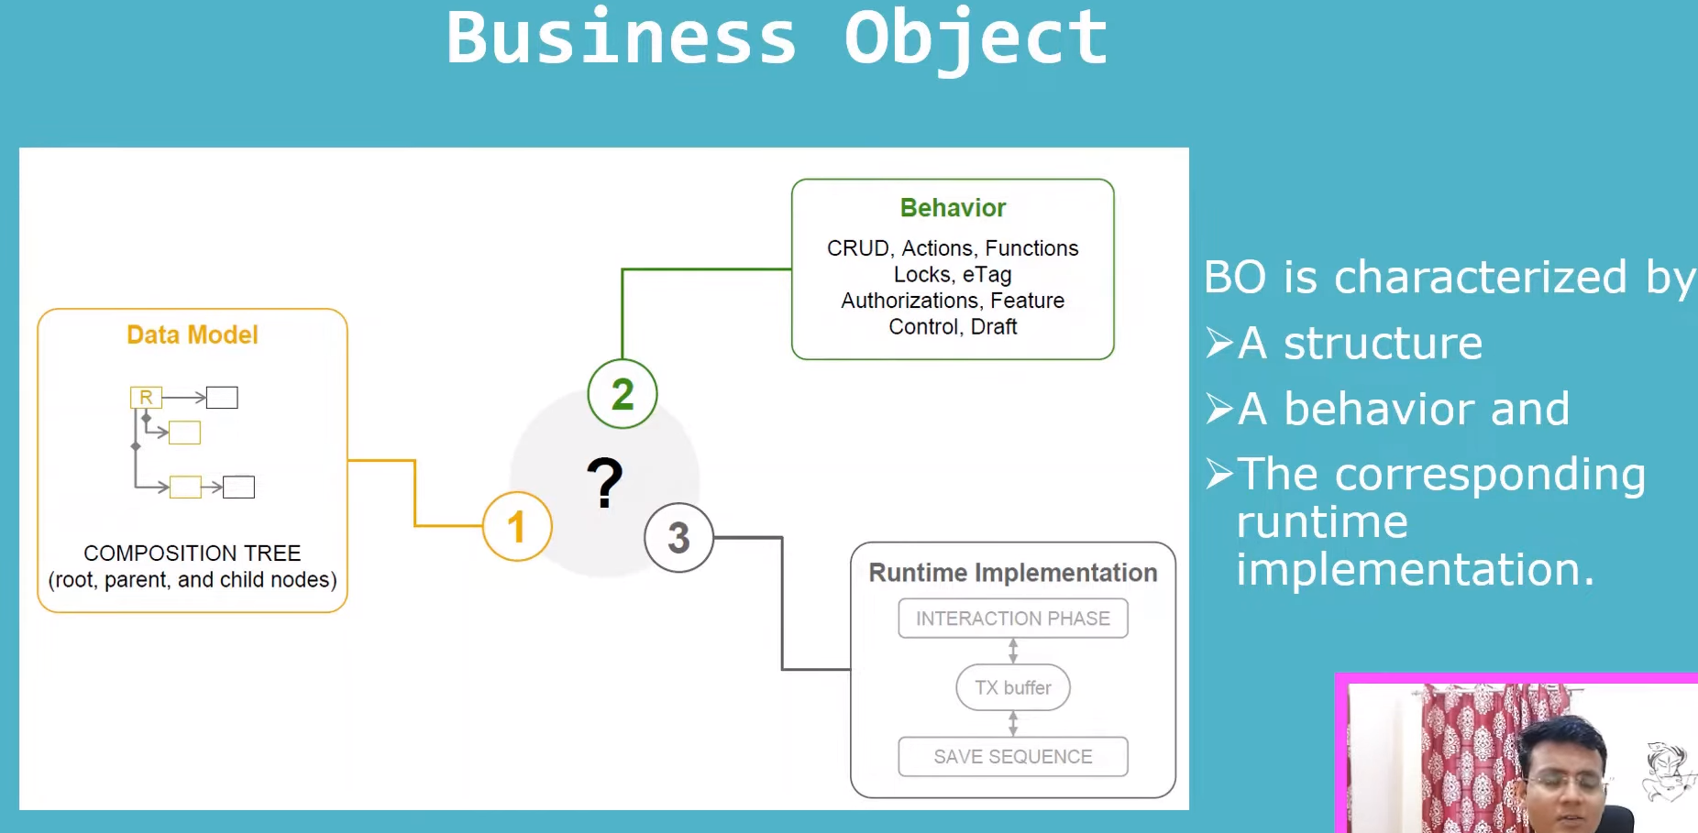

## Here we will concentrate on behavior and Runtime implementation;

### Behavior definitions:

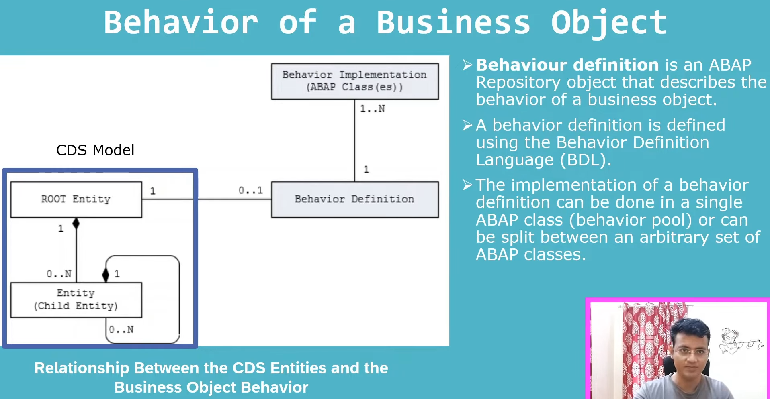

#### What is behavior?

1. Behavior defined by behavior definition.
2. Behavior definition object- is a abap repository object. Repository object contains reportrs/Fms… etc. SAP has introduced new repository object i.e behavior definition.
3. In Behavior definition, we will write the code in behavior definition language like reports we can write the code in abap same way we can write the bdl to write the code in behavior definition object.
4. What we will write in the behavior definition.?

#### What we will write in the behavior definition.

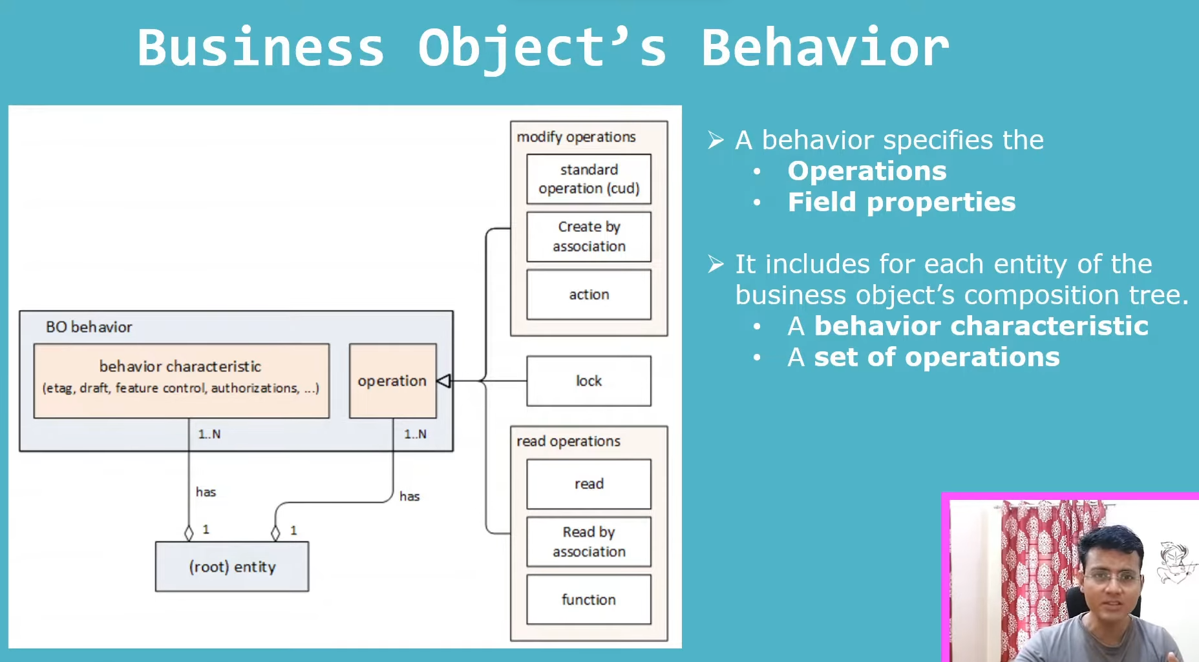

In the behavior definition, we will write two things

1. **Operation: C/U/D**

the particular business object, we can do multiple operations. Those operations we can define in the behavior definition. Like we want to create business object, you want to update/modify/delete, what all are the operations you can do on business object, that we can do in this behavior definition using the behavior definition language.

1. **Field Properties.:** You can define for particular field either read only or make the some of the fields are mandatory and we are giving some of the examples lot of things on the field properties like that this kind of things define in behavior definition.

Ex:

Suppose you create an application on front end for particular field and it should not be modifiable, when you click on edit mode, that kind of things, we will make it as read only in this behavior definition, then it automatically will not become a modifiable field in the front end.

Ex:

Same way front end field can mandatory, that we can define here this field is mandatory.

These all are field property we can define in behavior definitions.

#### What are things we can define in BO:

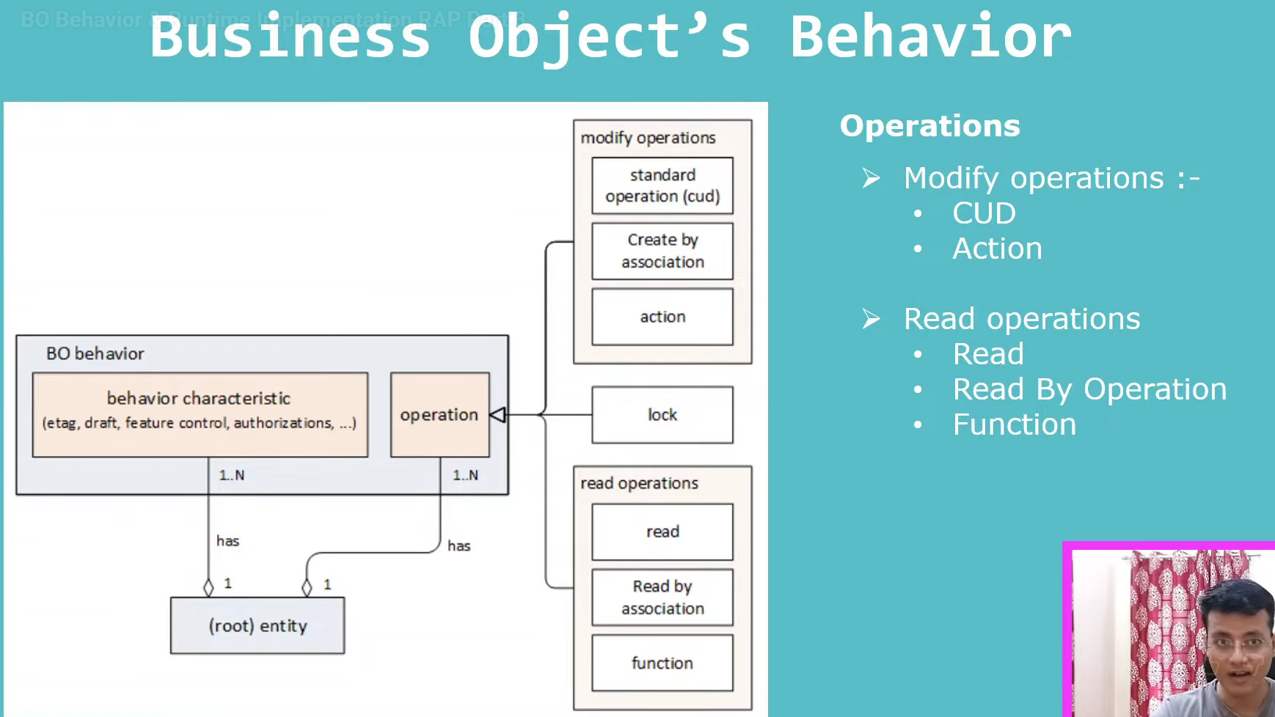

1. **Operations**:

**Modify Operations:**

1. C/U/D- Create(C)/Update(U)/Delete(D)
2. Action
   1. Ex:We can create/update/delete sales order, same way can approve/reject/do something other operations like modifications on the sales order level that we can do using the actions. this is also part of the behavior defintions.

**Read Operations:**

normal read we can do,

1. Read- Normal
2. Read by association- if we have multiple entities- we can do read by operation/associations we can do.
3. Function: is same as actions, action is do the modification in the system, but function will use for read operations. It is not used for modification operations.

#### Behavior Characteristics:

* This is also part Behavior definitions.
* In behavior definition language we have the operations like modification and read operations along with we have the behavior characteristics.
* behavior characteristics are:
  + Etag - Locking
  + Draft handling
  + Feature control
  + Numbering
  + Authorization control

#### Behavior Implementations:

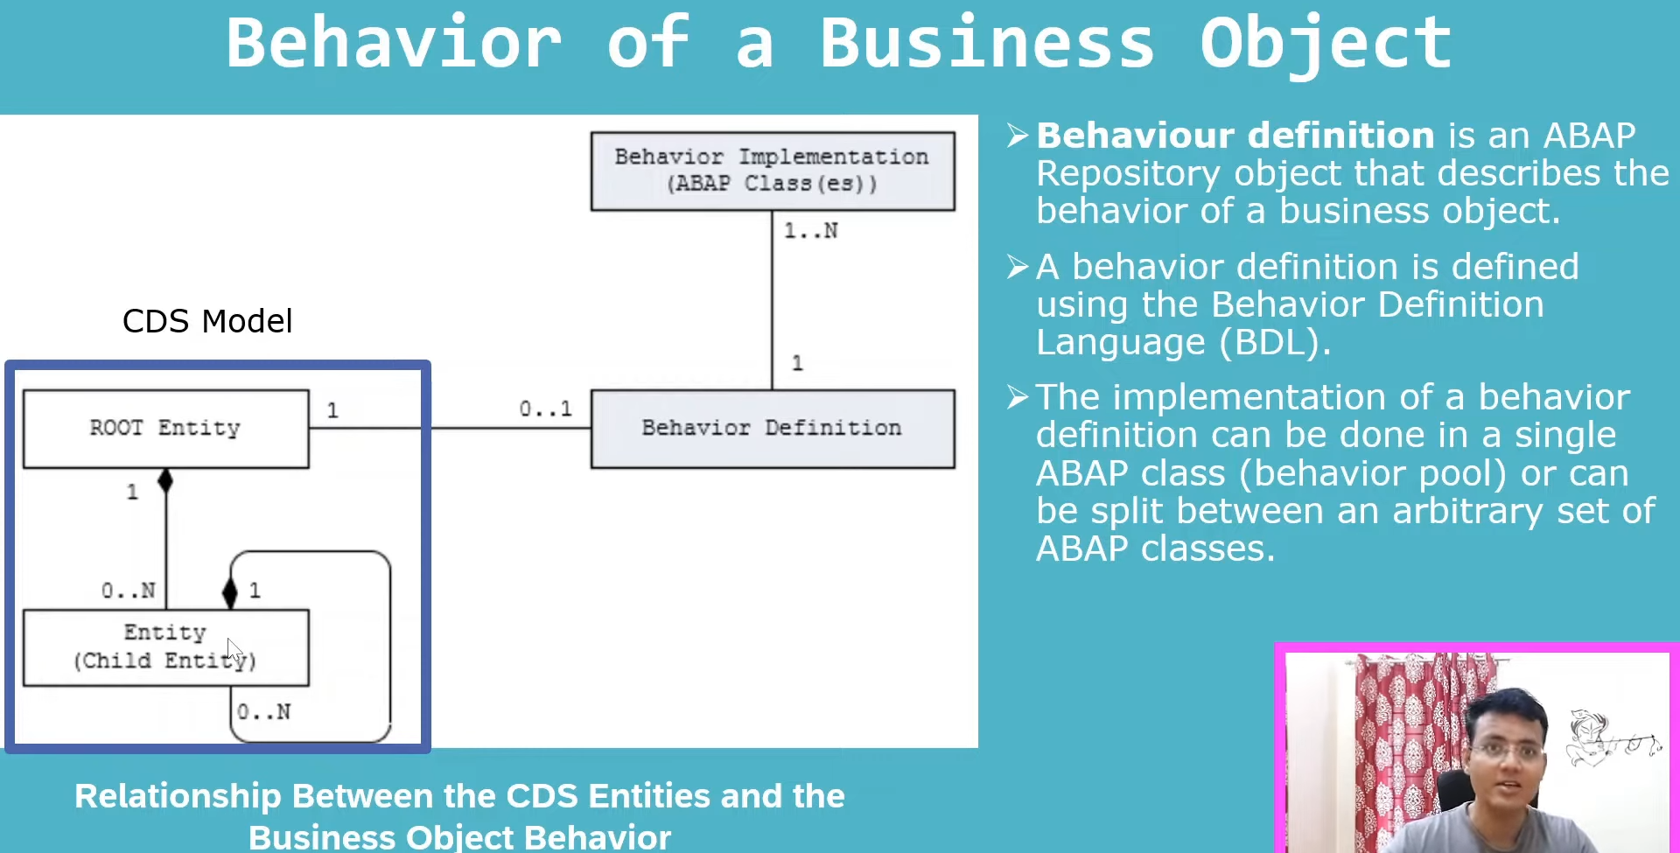

* We will implement the behavior definition in abap classes.
* One behavior definition, we can have n- number of implementations.
* Behavior Definition(1) 🡪 Behavior implementations(N). and BO will again map to the root entity and also it can be linked to other entities.
* Behavior definition contains- Operations(CRUD) and characteristics(ETAG/Numbering… etc).
* In implementations- real do the coding in abap classes based on Behavior definitions.

Example :

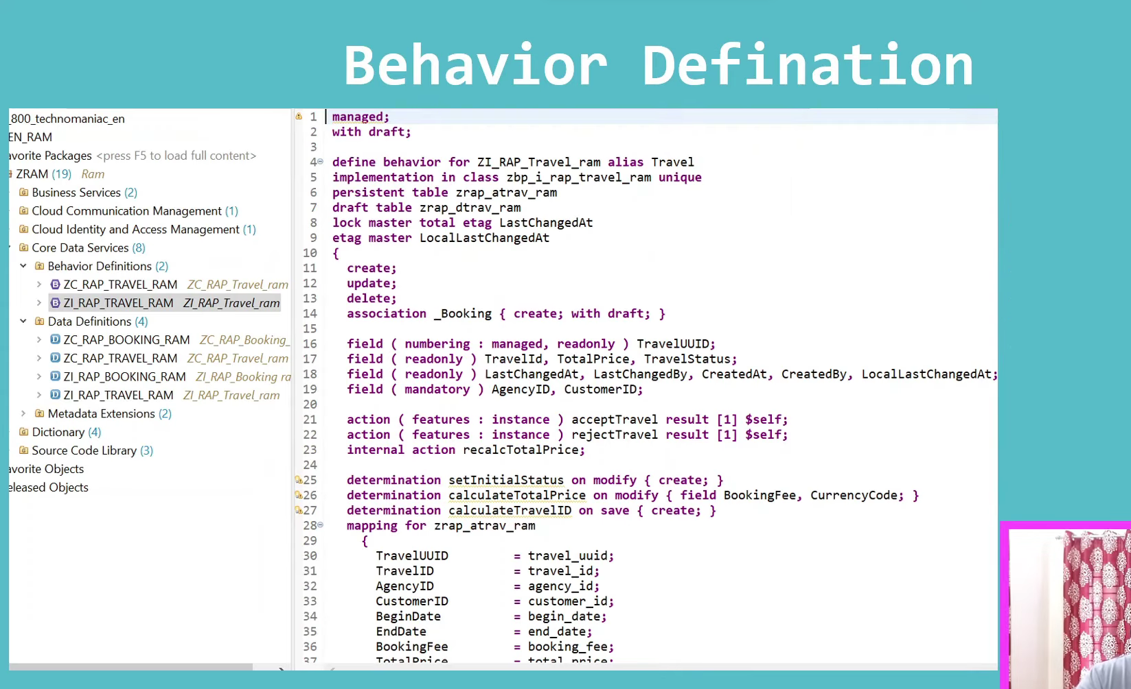

### Runtime Implementations:

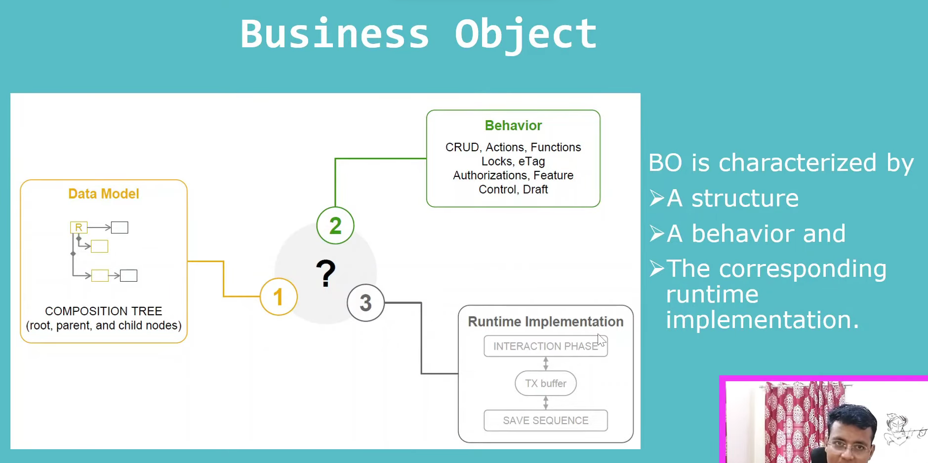

Before going to the runtime implementations, I just want to How the behavior definition available in the system on exist BO’s

Example : behavior definition



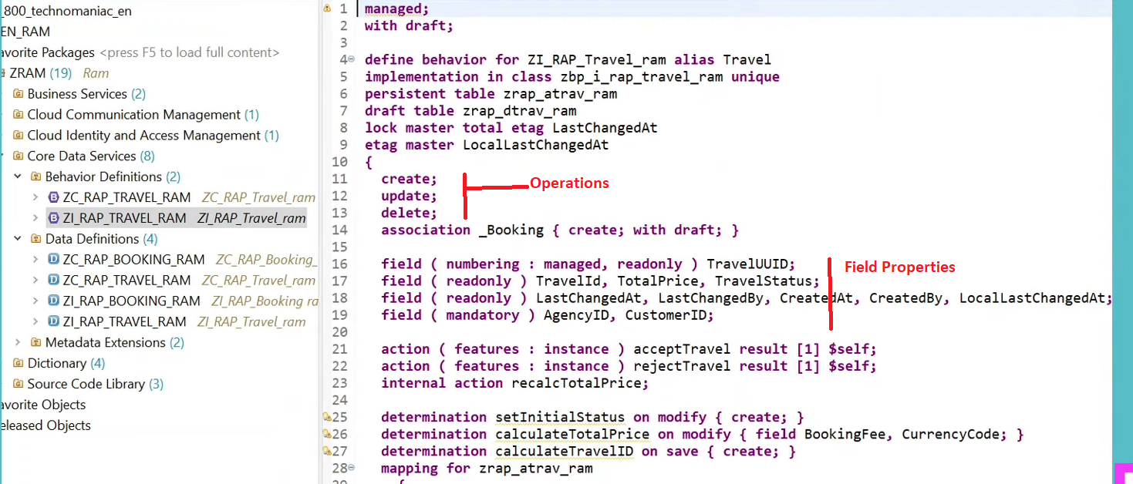

Runtime implementations:

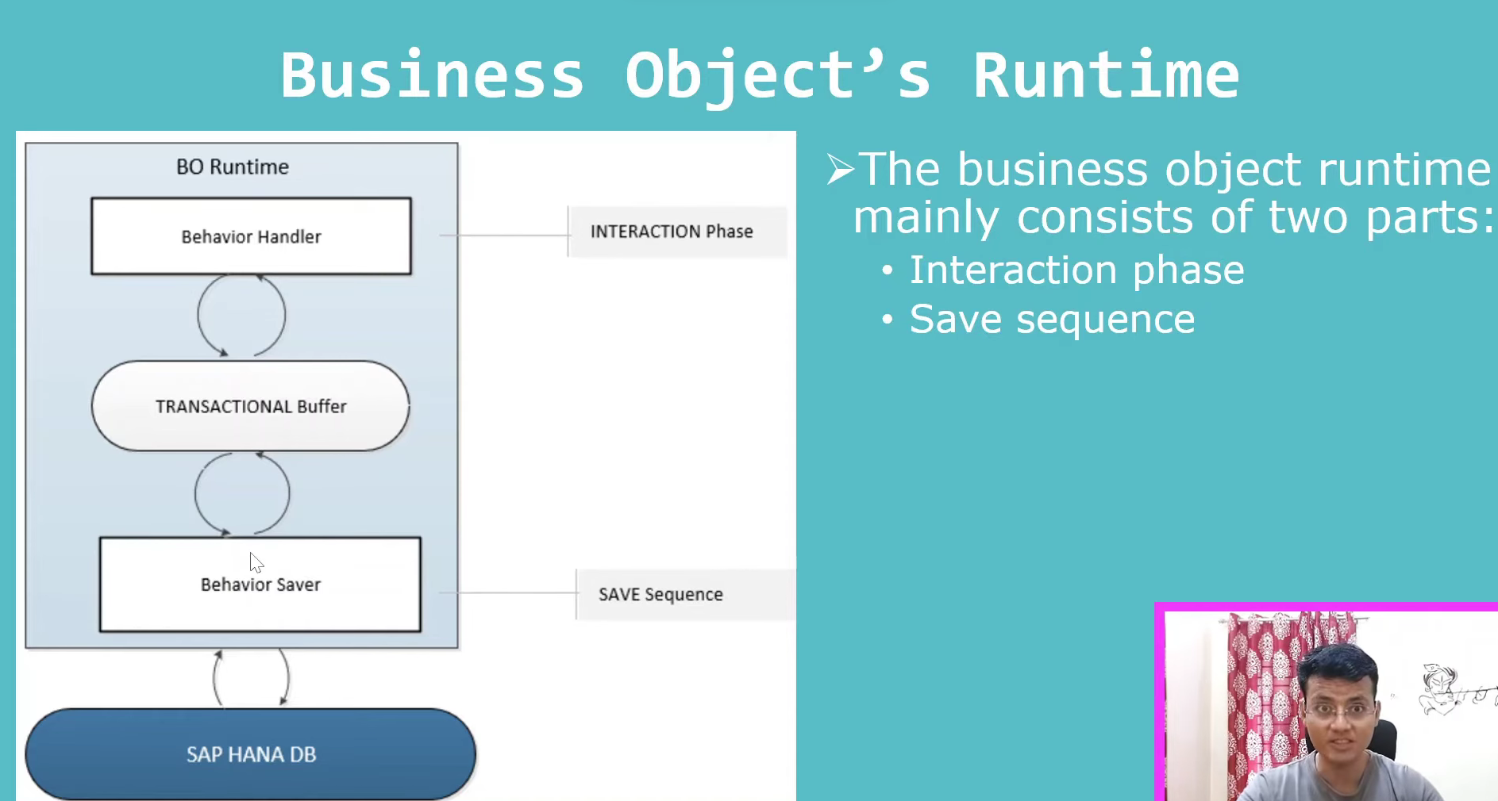

When you interact with the business object, then runtime part will come in the picture.

In runtime implementation: when user interact with the BO, either he wants to read the data and he want to do the transactional thing on the particular BO, that time all the things will be saved in transactional buffer.

BO runtime has two parts:

1. Interaction Phase. Use is interacting either reading/writing on BO, those all will be save in the transactional buffer.

Once user is satisfied, everything is done, when click on save button – save sequence will trigger.

1. Save sequence.: once interaction phase is done, user will click on save button, save sequence will trigger. And finally data save in HANA DB.

What is the transactional Buffer:?

* It is intermediate thing.
* It will save the data, when user interact with BO. Finally one particular Business object- instance, we will have the transactional buffer.
* Transactional Buffer can’t exist without the BO. For that particular instance what all are the data that will save under the transactional buffer, everything done, when user click on save, then it stores in DB level. Means persist data in DB level.

Note: We have the managed/ unmanaged scenarios for BO and queries also.